主题：日常消费

题型：柱状图

The bar chart below shows money spent on consumer goods in different countries.

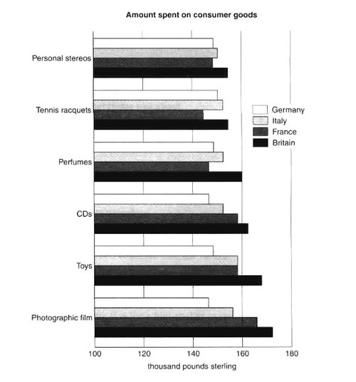

满分范文：

The bar chart compares consumer spending on six different items in Germany, Italy, France and Britain.

It is clear that British people spent significantly more money than people in the other three countries on all six goods. Of the six items, consumers spent the most money on photographic film.

People in Britain spent just over £170,000 on photographic film, which is the highest figure shown on the chart. By contrast, Germans were the lowest overall spenders, with roughly the same figures (just under £150,000) for each of the six products.

The figures for spending on toys were the same in both France and Italy, at nearly £160,000. However, French people spent more than Italians on photographic film and CDs, while Italians paid out more for personal stereos, tennis racquets and perfumes than others. The amount spent by French people on tennis racquets, around £145,000, is the lowest figure shown on the chart.